EXPERIMENT 14

Hypothetical Using ANOVA – Test

Aim:

To compare the growth rates of plants under three different fertilizer treatments (Treatment A,B and C) to determine if there is a significant difference in their mean growth.

Algorithm:

1. Import necessary libraries — numpy, scipy.stats, and statsmodels.

2. Generate or input data for multiple groups (e.g., different treatments).

3. Compute the mean of each group to observe basic differences.

4. Perform one-way ANOVA using stats.f_oneway() to compare group means.

5. Obtain the F-statistic and p-value from the ANOVA result.

6. Set a significance level (α), typically 0.05.

7. Compare the p-value with α to decide whether to reject the null hypothesis.

8. If rejected, perform Tukey’s HSD post-hoc test to find which groups differ significantly.

Program:

import numpy as np

import scipy.stats as stats

from statsmodels.stats.multicomp import pairwise_tukeyhsd

np.random.seed(42)

n_plants = 25

growth_A = np.random.normal(loc=10, scale=2, size=n_plants)

growth_B = np.random.normal(loc=12, scale=3, size=n_plants)

growth_C = np.random.normal(loc=15, scale=2.5, size=n_plants)

f_statistic, p_value = stats.f_oneway(growth_A, growth_B, growth_C)

print("Treatment A Mean Growth:", np.mean(growth_A))

print("Treatment B Mean Growth:", np.mean(growth_B))

print("Treatment C Mean Growth:", np.mean(growth_C))

print(f"\nF-Statistic: {f_statistic:.4f}")

print(f"P-Value: {p_value:.4f}")

alpha = 0.05

if p_value < alpha:

print("Reject the null hypothesis: Significant difference in mean growth among treatments.")

else:

print("Fail to reject the null hypothesis: No significant difference in mean growth among treatments.")

if p_value < alpha:

all_data = np.concatenate([growth_A, growth_B, growth_C])

labels = ['A'] * n_plants + ['B'] * n_plants + ['C'] * n_plants

tukey_results = pairwise_tukeyhsd(all_data, labels, alpha=0.05)

print("\nTukey's HSD Post-hoc Test:")

print(tukey_results)

Output:

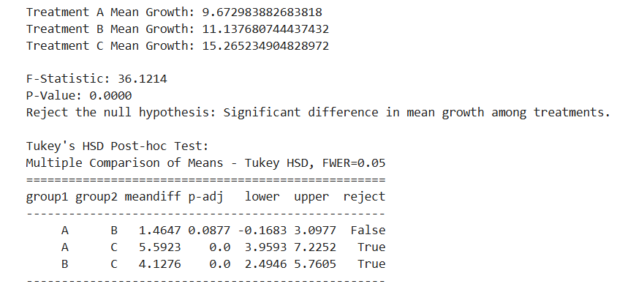

Result:

Hence a python program for hypothetical ANOVA- Test is written and executed successfully.